Conflict Sensitivity Specialist

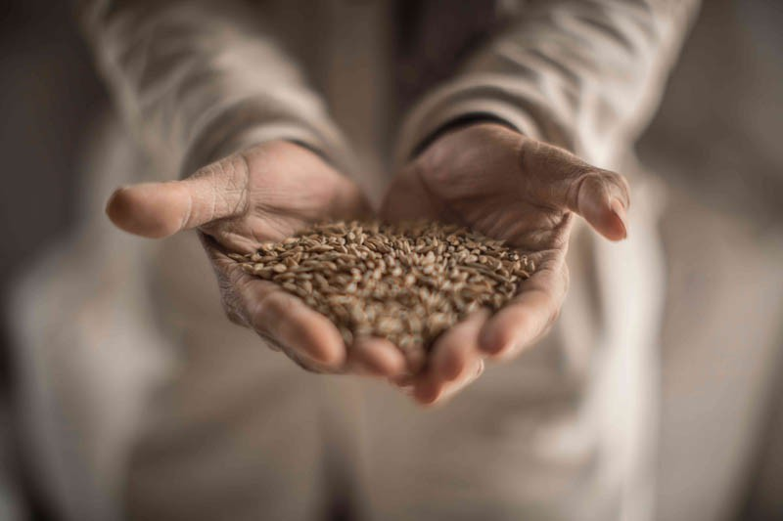

Who are we?
The Danish Refugee Council assists refugees and internally displaced persons across the globe: we provide emergency aid, fight for their rights, and strengthen their opportunities for a brighter future. We work in conflict-affected areas, along the displacement routes, and in the countries where refugees settle. In cooperation with local communities, we strive for responsible and sustainable solutions. We work toward successful integration and – whenever possible – for the fulfillment of the wish to return home.
The Danish Refugee Council was founded in Denmark in 1956 and has since grown to become an international humanitarian organization with more than 7,000 staff and 8,000 volunteers. Our vision is a dignified life for all displaced.
All of our efforts are based on our value compass: humanity, respect, independence and neutrality, participation, and honesty and transparency.

DRC Syria
DRC has been operating in Syria since 2008, initially responding to the Iraqi refugee crisis before pivoting to a full-scale response to the Syria crisis from 2011 onwards. Our work encompasses the full cycle of displacement—responding to life-saving humanitarian needs and supporting community recovery until durable solutions can be achieved. DRC Syria takes an area-based approach to supporting internally displaced persons (IDPs), returnees, and host communities across our key sectors: Economic Recovery and Resilience, Protection, WASH, Shelter and Infrastructure, and Humanitarian Disarmament and Peacebuilding (including Humanitarian Mine Action).
With an established rapid response mechanism, DRC can rapidly respond to emerging crises and shocks to meet acute emergency needs. Recognizing the significant need for early recovery and resilience programming to ensure dignified, sustainable, and cost-effective solutions for fragile

Tip a friend Print

APPLY FOR POSITION

Application due:
5/31/2026

Workplace:
Damascus

Department/Country:
Syria

Contract type:
National contract

Homepage:
drc.ngo

ABOUT DRC

communities, DRC’s programmes foster resilience for individuals and communities in situations of protracted displacement and during the initial stages of post-conflict recovery, towards a durable solution of their choice. With active portfolios in the neighboring countries of Jordan, Lebanon, Türkiye and Iraq, DRC offers a cross-border, regional response to the Syria crisis, through cross-border protection monitoring, advocacy, and trends analysis.

Overall Purpose of the Role
The program is seeking to establish its peacebuilding component, including conflict sensitivity, and to identify new and innovative methods for the development of DRC’s peacebuilding programming. DRC is also planning to mainstream conflict sensitivity across its entire mission in Syria. HDP is seeking a dynamic person to fill the role of Conflict Sensitivity and Peacebuilding Specialist for its Syria programme.
The Specialist will support the development and implementation of activities promoting peace and social cohesion, conduct peacebuilding-relevant research and conflict analysis, and esure conflict sensitivity of all DRC activities. The Specialist will also develop and maintain networks of relevant (non-)governmental partners and interlocutors as well as draft quality reports for donors and other country- and HQ-level communications. The role is also expected to mentor and conduct capacity building of relevant staff based in Area Offices (requiring travel to field locations, e.g. Rural Damascus, Dara’a, Aleppo).
The Specialist will also contribute to fundraising for peacebuilding activities as well as to project monitoring, evaluation and reporting.

Responsibilities:

Conflict Analysis and Conflict Sensitivity
Conduct conflict analysis (including gender analyses) and support the operationalization of conflict analysis results as well as provide recommendations for peacebuilding programming to HDP and make suggestions for integrated PB activities with other sectors
Mainstream conflict sensitivity across the DRC Syria mission.
Support the planning, design and implementation of conflict sensitivity assessments across the mission and work closely with other DRC sectors in carrying out these assessments and ensure that they are updated and shared with relevant DRC staff.
Based on conflict sensitivity assessments, provide conflict sensitivity recommendations to DRC sectors and guidance on how to implement them.
Support the design of peacebuilding, conflict management and conflict sensitivity trainings and workshops for DRC staff across the mission, partners and other relevant external actors.

Programme Development
Support with the development of high quality proposals, in coordination with other DRC sector leads, other DRC Specialists and Head of HDP.
Conduct mapping(s) of local, regional and national peacebuilding actors whose vision, mission and values align with DRC and hold potential for partnerships, in coordination with the DRC Partnership team.
Support the identification of new and innovative methods for the development of DRC’s peacebuilding programming across Syria and monitor trends and practices from the broader peacebuilding, social cohesion and dialogue/mediation communities.
Develop assessments, studies, reviews and evaluations in close coordination with HDP and other sector leads.
Work closely with other sector leads to identify and develop areas for integration of HDP within DRC’s broader programmatic portfolio.

Project Management
Coordinate the implementation of peacebuilding initiatives aimed at addressing the root causes of conflict, promoting reconciliation, and fostering social cohesion.
Collaborate with project teams and partners to ensure timely and effective delivery of project outputs, including organizing workshops, training sessions, and community dialogues.
Work closely with the HDP team and the program MEAL/ Information Management staff to carry out monitoring, and to ensure credible, best-practice monitoring and reporting of program activities.
Lead the communication with partner organizations, external experts and consultants, including monitoring of quality assurance with regard to activities in the context of peacebuilding.
Provide monitoring of financial commitments and expenditures of peacebuilding projects against budgets and provide timely feedback on budget follow-up.
Perform monitoring and field visits to locations where partners and DRC staff are based in different areas of Syria.

Other
Founded in 1956, DRC Danish Refugee Council is Denmark’s largest, and a leading international NGO. We have continuously been ranked as one of the best NGOs in the world - and are one of the few with a specific expertise in forced displacement. In around 30 countries, we protect, advocate and build sustainable futures for refugees and other displacement-affected people and communities.

Ensure adherence to DRC’s Age, Gender, and Diversity policy and AGD programmatic minimum standards.
Ensure compliance with zero-tolerance to Sexual Exploitation and Abuse policy.
Perform other relevant tasks as requested by and in discussion with the Head of Programme.

Experience and technical competencies: (
Essential
At least 3 years of direct work experience in peacebuilding, social cohesion, conflict analysis, conflict management programming.
Experience in capacity building and training of staff in social cohesion and peacebuilding programming, and/or conflict management, mediation, and dialogue facilitation.
Demonstrated commitment to apply an age, gender and diversity (AGD) and conflict sensitive approach to programming.
Experience working with national partners in social cohesion initiatives. Experience working in the NGO sector.
Innovative and creative thinking with strong analytical and reporting skills
Political and cultural sensitivity, as well as a diplomatic, tactful, and flexible interpersonal style. Ability to set priorities and to work independently and as part of a team.
Strong organizational skills and attention to detail. Good interpersonal and communication skills.
Excellent skills in MS Word, Excel, and PowerPoint.

Education/qualifications:
University degree in political science, international development, peace and conflict studies or other relevant field.
Practical trainings or courses in peacebuilding, conflict management, mediation and dialogue facilitation.

Languages:
Full professional proficiency in English; Fluency in Arabic.

In this position, you are expected to demonstrate DRC’ five core competencies:
Striving for excellence: You focus on reaching results while ensuring an efficient process.
Collaborating: You involve relevant parties and encourage feedback.
Taking the lead: You take ownership and initiative while aiming for innovation.
Communicating: You listen and speak effectively and honestly.
Demonstrating integrity: You act in line with our vision and values.

We offer:
Contract length: 6 months 6 months with possibility of extension (subject to funding)
Level: G level 2 (Non-Management) (In accordance to DRC's salary scale)
Location: Damascus, with countrywide trave
Expected Start date: 1 July 2026

Application process
Interested? Then apply for this position by clicking on one of the links below: Direct application link:Talentech - Conflict Sensitivity Specialist - Application Form
All applicants must send a cover letter and an updated CV (no longer than four pages). Both must be in English language as this vacancy note. CV only applications will not be considered.
Applications close on: 31 May 2026
DRC reserves the right to conduct tests and interviews before the closing date and can close the advertisement earlier in case of finding a suitable candidate.

Need further information?


For further information about the Danish Refugee Council, please consult our website www.drc.org

DRC as an employer
By working in DRC, you will be joining a global workforce of around 6000 employees in approximately 30 countries. We pride ourselves on our:
Professionalism, impact & expertise Humanitarian approach & the work we do Purpose, meaningfulness & own contribution Culture, values & strong leadership
Fair compensation & continuous development

DRC’s capacity to ensure the protection of and assistance to refugees, IDP’s and other persons of concern depends on the ability of our staff to uphold and promote the highest standards of ethical and professional conduct in relation DRC’s values and Code of Conduct, including safeguarding against sexual exploitation, abuse and harassment. DRC conducts thorough and comprehensive background checks as part of the recruitment process.

If you have questions or are facing problems with the online application process, please visit drc.ngo/jobsupport.

Danish Refugee Council is an equal opportunity employer and we consider all applicants based on individual merit and qualifications, regardless of personal characteristics or attributes. We are committed to increasing the diversity of our workforce, aiming for a 50% balance of men and women in management roles and ensuring that at least 50% of management roles are filled by national staff. We recognize that a diverse and inclusive team is crucial for achieving our organizational goals and making a positive impact on the communities we serve.

About DRC
DRC Dansk Flygtningehjælp

03:07

Apply for position

