
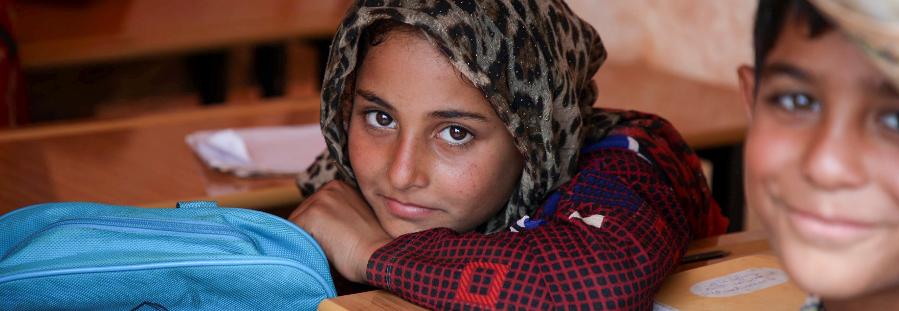
EXTERNAL VACANCY ANNOUNCEMENT

If you are a committed, creative Syrian and are passionate about making a lasting difference for children, the world's leading child rights organization, UNICEF would like to hear from you.

National Consultant - Capacity Building PSEA for Government Ministry, Damascus, Syria, Nationals ONLY
Job no: 593637

HOW TO APPLY

Please apply following the link below:
Link

Not later than 24 June 2026

For 70 years, UNICEF has been working on the ground in 190 countries and territories to promote children’s survival, protection and development. The world’s largest provider of vaccines for developing countries, UNICEF supports child health and nutrition, good water and sanitation, quality basic education for all boys and girls, and the protection of children from violence, exploitation, and AIDS.

UNICEF is committed to diversity and inclusion within its workforce, and encourages all candidates, irrespective of gender, nationality, religious and ethnic backgrounds, including persons living with disabilities, to apply to become a part of the organization.

UNICEF has a zero-tolerance policy on conduct that is incompatible with the aims and objectives of the United Nations, including sexual exploitation and abuse, sexual harassment, abuse of authority and discrimination. UNICEF also adheres to strict child safeguarding principles. All selected candidates will, therefore, undergo rigorous reference and background checks, and will be expected to adhere to these standards and principles.

For additional information on UNICEF, please visit our website http://jobs.unicef.org

UNICEF is a smoke-free environment.

Only shortlisted candidates will be contacted and advance to the next stage of the selection process.

