Protection Team Leader - Rural Damascus

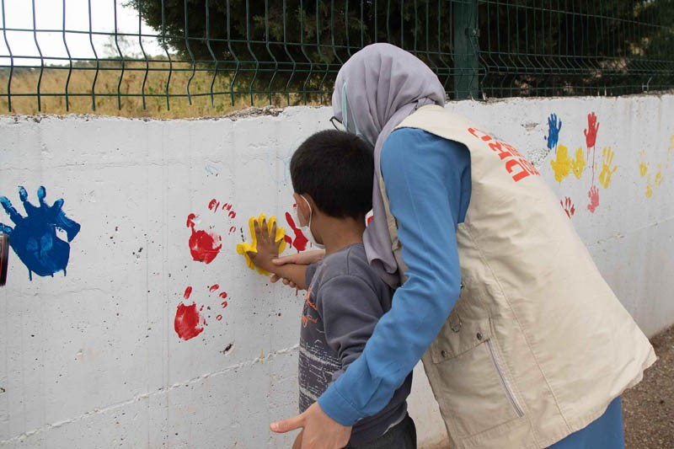

Who are we?
The Danish Refugee Council assists refugees and internally displaced persons across the globe: we provide emergency aid, fight for their rights, and strengthen their opportunities for a brighter future. We work in conflict-affected areas, along the displacement routes, and in the countries where refugees settle. In cooperation with local communities, we strive for responsible and sustainable solutions. We work toward successful integration and – whenever possible – for the fulfillment of the wish to return home.
The Danish Refugee Council was founded in Denmark in 1956 and has since grown to become an international humanitarian organization with more than 7,000 staff and 8,000 volunteers. Our vision is a dignified life for all displaced.
All of our efforts are based on our value compass: humanity, respect, independence and neutrality, participation, and honesty and transparency.

DRC Syria
DRC has been operating in Syria since 2008, initially responding to the Iraqi refugee crisis before pivoting to a full-scale response to the Syria crisis from 2011 onwards. Our work encompasses the full cycle of displacement—responding to life-saving humanitarian needs and supporting community recovery until durable solutions can be achieved. DRC Syria takes an area-based approach to supporting internally displaced persons (IDPs), returnees, and host communities across our key sectors: Economic Recovery and Resilience, Protection, WASH, Shelter and Infrastructure, and Humanitarian Disarmament and Peacebuilding (including Humanitarian Mine Action).
With an established rapid response mechanism, DRC can rapidly respond to emerging crises and shocks to meet acute emergency needs. Recognizing the significant need for early recovery and resilience programming to ensure dignified, sustainable, and cost-effective solutions for fragile

Tip a friend Print

APPLY FOR POSITION

Application due:
6/9/2026

Workplace:
Rural Damascus

Department/Country:
Syria

Contract type:
National contract

Homepage:
drc.ngo

ABOUT DRC

communities, DRC’s programmes foster resilience for individuals and communities in situations of protracted displacement and during the initial stages of post-conflict recovery, towards a durable solution of their choice. With active portfolios in the neighboring countries of Jordan, Lebanon, Türkiye and Iraq, DRC offers a cross-border, regional response to the Syria crisis, through cross-border protection monitoring, advocacy, and trends analysis.

About the job
Under direct management of DRC Syria Area Manager and under the technical supervision of DRC Syria Protection Manager, the Protection Team Leader is responsible for high quality implementation of ongoing protection activities and direct line management of Protection Field Assistants in Rural Damascus.

Duties and Responsibilities:
- Ensure high quality and timely implementation of protection activities within the projects assigned by line manager and according to DRC guidelines and Standard Operating Procedures.
- Support recruitment of protection field staff. Line manage Protection Field Assistants, and provide necessary technical support and oversight; manage internal staffing issues including attendance monitoring, leave plans and appraisals in coordination with line manager.
- Prepare, implement and report regularly on the status of project work plans; regularly update project indicator tracker.
- Maintain financial oversight of all protection budget lines as assigned by line manager, and ensure proper tracking of purchase requisitions and payment requests.
- Maintain records of protection activities in line with DRC SOPs and formats, ensuring confidentiality and data protection standards.
- Support the implementation of monitoring and evaluation (M&E) plan in coordination with the DRC M&E team.
- Liaise with relevant authorities, stakeholders, and community groups in order to foster positive relationships and facilitate ownership of prioritizing and improving the safety and well-being of crisis affected individuals and communities.
- Provide regular timely internal reports and other relevant information on project activities and external meetings based on agreed formats and schedule.
- Provide inputs and data from the field implementation for new proposal development.
- Conduct duties in accordance DRC Code of Conduct and with DRC Syria programme Standard Operating Procedures (SOPs).
- Ensure transparency and DRC’s positive regard and reputation within communities.
- Carry out any other relevant duties as assigned by the line manager.

Experience and Technical Competencies:
- Relevant professional experience of no less than 3 years. Experience of work in the UN or NGO or voluntary sector is essential. Familiarity/prior experience with DRC and its persons of concern (including internally displaced persons, returnees, refugees) would be a distinct advantage.
- Experience managing a team with proven leadership qualities including decision making.
- Familiarity with international protection and human rights legal standards, as well as with child protection and psychosocial support programming.
- Excellent writing and reporting skills, strong analytical skills.
- Excellent organizational and planning skills. Punctuality and respect for applicable rules and procedures.
- Excellent interpersonal skills and respect for people from diverse communities, and for persons with special needs and other vulnerabilities.
- Excellent knowledge and understanding of local communities and customary rules, demonstrated experience of successful community engagement.
- Ability to work with minimal supervision and as part of a team, self-motivation, goal/result-orientation.
- Ethical and transparent decision-making, full respect for confidentiality of work-related information and data.
- Flexibility, creativity, tolerance and maturity.
- Excellent spoken and written English/Arabic and relevant computer skills.
- Computer/IT literacy (Microsoft Officer Package (Word, Excel, Outlook in particular) Internet etc.).

Education:
- University degree in social sciences, psychology or other relevant field.
- Advanced university degree would be an asset.

Languages:
Strong spoken and written English Fluent spoken and written Arabic
In this position, you are expected to demonstrate DRC’ five core competencies:
Founded in 1956, DRC Danish Refugee Council is Denmark’s largest, and a leading international NGO. We have continuously been ranked as one of the best NGOs in the world - and are one of the few with a specific expertise in forced displacement. In around 30 countries, we protect, advocate and build sustainable futures for refugees and other displacement-affected people and communities.

Striving for excellence: You focus on reaching results while ensuring an efficient process.
Collaborating: You involve relevant parties and encourage feedback.
- Taking the lead: You take ownership and initiative while aiming for innovation.
- Communicating: You listen and speak effectively and honestly.
- Demonstrating integrity: You act in line with our vision and values.

We offer:
- Contract length: Until the end of December 2026
- Level: Management G
- Location: Rural Damascus- Syria

Expected Start date: ASAP

Application process
Interested? Then apply for this position by clicking on one of the links below:
Direct application link: Talentech - Protection Team Leader - Rural Damascus - Application Form
All applicants must send a cover letter and an updated CV (no longer than four pages). Both must be in the same language as this vacancy note. CV only applications will not be considered.
Applications close on: 31 May 2026
DRC reserves the right to conduct tests and interviews before the closing date and can close the advertisement earlier in case of finding a suitable candidate.

Need further information?
For further information about the Danish Refugee Council, please consult our website www.drc.org

DRC as an employer
By working in DRC, you will be joining a global workforce of around 6000 employees in approximately 30 countries. We pride ourselves on our:
- Professionalism, impact & expertise
- Humanitarian approach & the work we do
- Purpose, meaningfulness & own contribution
- Culture, values & strong leadership
- Fair compensation & continuous development

DRC’s capacity to ensure the protection of and assistance to refugees, IDP’s and other persons of concern depends on the ability of our staff to uphold and promote the highest standards of ethical and professional conduct in relation DRC’s values and Code of Conduct, including safeguarding against sexual exploitation, abuse and harassment. DRC conducts thorough and comprehensive background checks as part of the recruitment process.

If you have questions or are facing problems with the online application process, please visit drc.ngo/jobsupport.

Danish Refugee Council is an equal opportunity employer and we consider all applicants based on individual merit and qualifications, regardless of personal characteristics or attributes. We are committed to increasing the diversity of our workforce, aiming for a 50% balance of men and women in management roles and ensuring that at least 50% of management roles are filled by national staff. We recognize that a diverse and inclusive team is crucial for achieving our organizational goals and making a positive impact on the communities we serve.


Apply for position
03:07
About DRC
DRC Dansk Flygtningehjælp

